Reference: https://developer.chrome.com/docs/devtools/overview

Chrome DevTools is a powerful set of web development tools integrated into Google Chrome that allows developers to inspect, debug, and optimize web applications.

1. Getting Started with Chrome DevTools
To open Chrome DevTools:
- Right-click on any webpage element and select Inspect.
- Or, press F12 (Windows) / Cmd + Option + I (Mac).
- You can also access it through Menu > More tools > Developer tools.

2. The DevTools UI Overview
The DevTools interface is organized into multiple panels, each designed to assist with different aspects of web development:
- Elements: Inspect and modify HTML/CSS.
- Console: Execute JavaScript and log data.
- Sources: View and debug JavaScript.
- Network: Monitor network requests.
- Performance: Record and analyze runtime performance.
- Memory: Profile memory usage.
- Application: Manage storage, caches, and service workers.
- Security: Check security information.
- Lighthouse: Run audits to analyze and improve page performance.

3. Elements Panel
The Elements panel allows you to inspect and modify HTML and CSS in real-time.
- Inspect Elements: Hover over the HTML structure to see the corresponding visual element highlighted on the page.
- Editing HTML and CSS: Double-click any element or CSS property to edit.
- CSS Box Model: View the box model (margin, border, padding) in the right sidebar.
- Styles Tab: Modify CSS rules and see changes immediately.
- Layout Tab: View grid and flexbox layout options.
- Event Listeners: View active JavaScript event listeners on elements.

4. Console Panel
The Console panel is used to execute JavaScript, debug, and view error messages.
- Logging: Use console.log(), console.error(), console.warn() for debugging.
- Executing Commands: You can write and execute JavaScript expressions directly.
- Filtering: Filter messages by type (e.g., log, error, warning).
- Access Elements: Use $0, $1 to reference elements selected in the Elements panel.

5. Sources Panel
The Sources panel is a comprehensive JavaScript debugging environment.
- File Navigator: View and open all resources associated with the page.
- Breakpoints: Set breakpoints by clicking on line numbers. You can use various types, such as line breakpoints, conditional breakpoints, and DOM breakpoints.
- Watch Expressions: Monitor specific variables or expressions.
- Call Stack: View the call stack to trace function calls.
- Scope: Inspect local and global variables.
- Step Through Code: Use Step Over (F10), Step Into (F11), and Step Out (Shift+F11) to navigate.

6. Network Panel
The Network panel is essential for analyzing and troubleshooting network requests.
- Monitoring Requests: Shows all requests, their status, and response times.
- Throttling: Simulate slower network speeds to test loading under various conditions.
- Inspecting Headers and Data: View request/response headers, cookies, and payloads.
- XHR and Fetch: Filter and view XMLHttpRequest and Fetch API calls.
- Performance Analysis: Look at resource loading times and prioritize optimization efforts.

7. Performance Panel
The Performance panel helps you record and analyze the runtime performance of your page.
- Record Profile: Click "Record" to capture page interactions and load time.
- Flame Chart: Shows the time spent in each function during the recording.
- Frame Analysis: Helps identify bottlenecks in rendering and paint times.
- Screenshots: Capture screenshots during the recording for visual reference.
- Analyze Metrics: View FPS, CPU load, and memory usage during the recording.

8. Memory Panel
The Memory panel is useful for detecting and managing memory leaks.
- Heap Snapshot: Take snapshots of memory usage at different times to identify memory leaks.
- Allocation Sampling: See which functions are allocating the most memory.
- Allocation Timeline: Track memory allocations over time.
- Identify Leaks: Use the retained size and detached DOM tree features to find potential memory leaks.

9. Application Panel
The Application panel allows you to manage and inspect web storage and resources.
- Storage: View and manage Local Storage, Session Storage, IndexedDB, Web SQL, and cookies.
- Service Workers: Inspect active service workers and caches.
- Cache: View cached assets in Application Cache and Cache Storage.
- Manifest: View PWA manifest and check compatibility.
- Background Sync & Push: Test and debug background synchronization and push notifications.

10. Security Panel
The Security panel gives information on the security of the website.
- Certificates: Check SSL certificates for validity and issues.
- Security Warnings: Identify mixed-content warnings or insecure resources.
- Security Status: Verify if the site is fully secure and encrypted.

11. Lighthouse Panel
The Lighthouse panel provides an automated analysis of the web page’s performance, accessibility, SEO, and more.
- Generate Reports: Run audits to generate reports.
- Review Recommendations: See specific recommendations to improve performance, accessibility, and best practices.
- Performance Score: Get a performance score and learn how to improve page speed.

12. More Tools and Customization
The DevTools interface can be customized and expanded with additional tools and shortcuts:
- More Tools Menu: Access tools like Coverage, Rendering, and Animations.
- Dock Position: Adjust the DevTools window position (bottom, side, or separate window).
- Device Mode: Simulate mobile and tablet devices with device emulation.
- Shortcuts: Learn keyboard shortcuts to speed up your workflow.

Tips and Best Practices
- Use Console for Quick Debugging: Use console.log() and similar commands to track variable values.
- Throttling: Always test on simulated slower networks to ensure good user experience.
- Use Responsive Design Mode: Test page responsiveness on various devices.
- Use Persistent Console Logs: In Console settings, enable "Preserve log" to keep logs between page reloads.

Lab Tasks
- Each group will choose one existing website for experimentation which is similar to their selected project topic. For example: https://www.foodpanda.com.bd/

- Open DevTools (Ctrl + Shift + C). Click on an element.
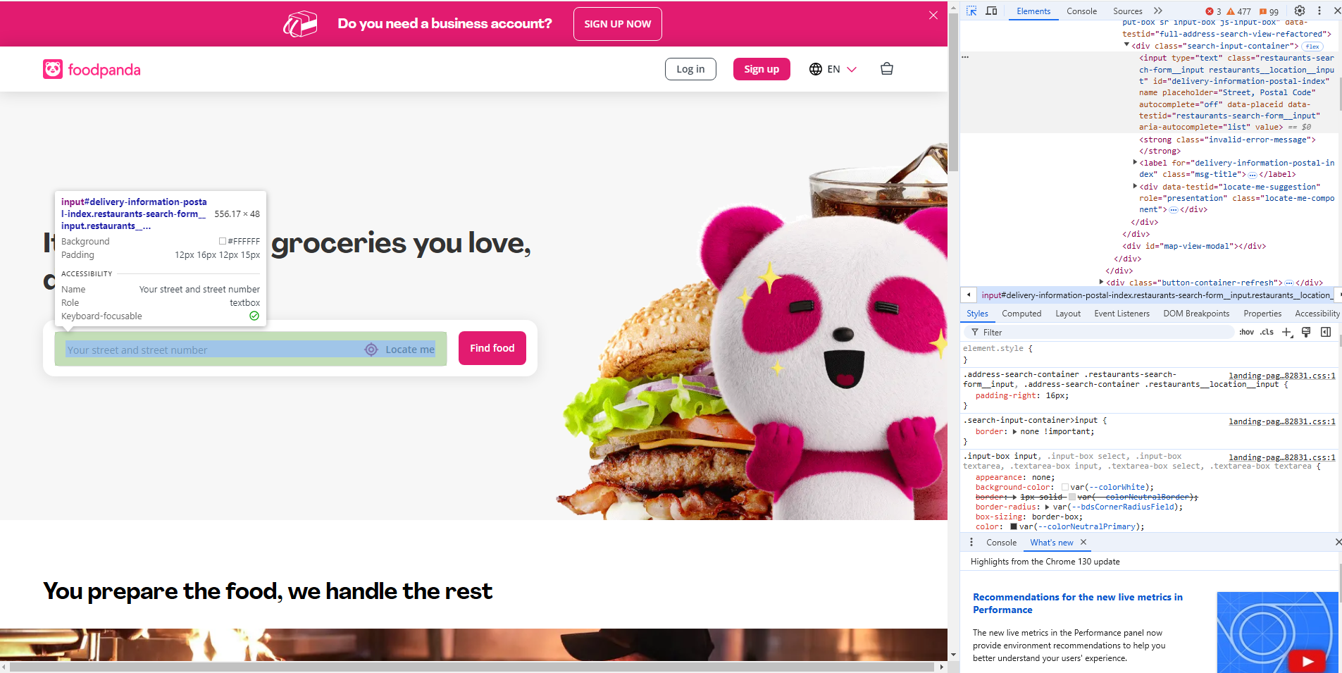

- Use the inspect() method in the console, such as inspect(document.body). See the Command-Line API for information on using inspect.

- Navigate through the DOM structure using either mouse or keyboard. To expand a collapsed node , click the node. As you navigate, the Elements panel shows a breadcrumb trail in the bottom bar.

- View element event listeners.
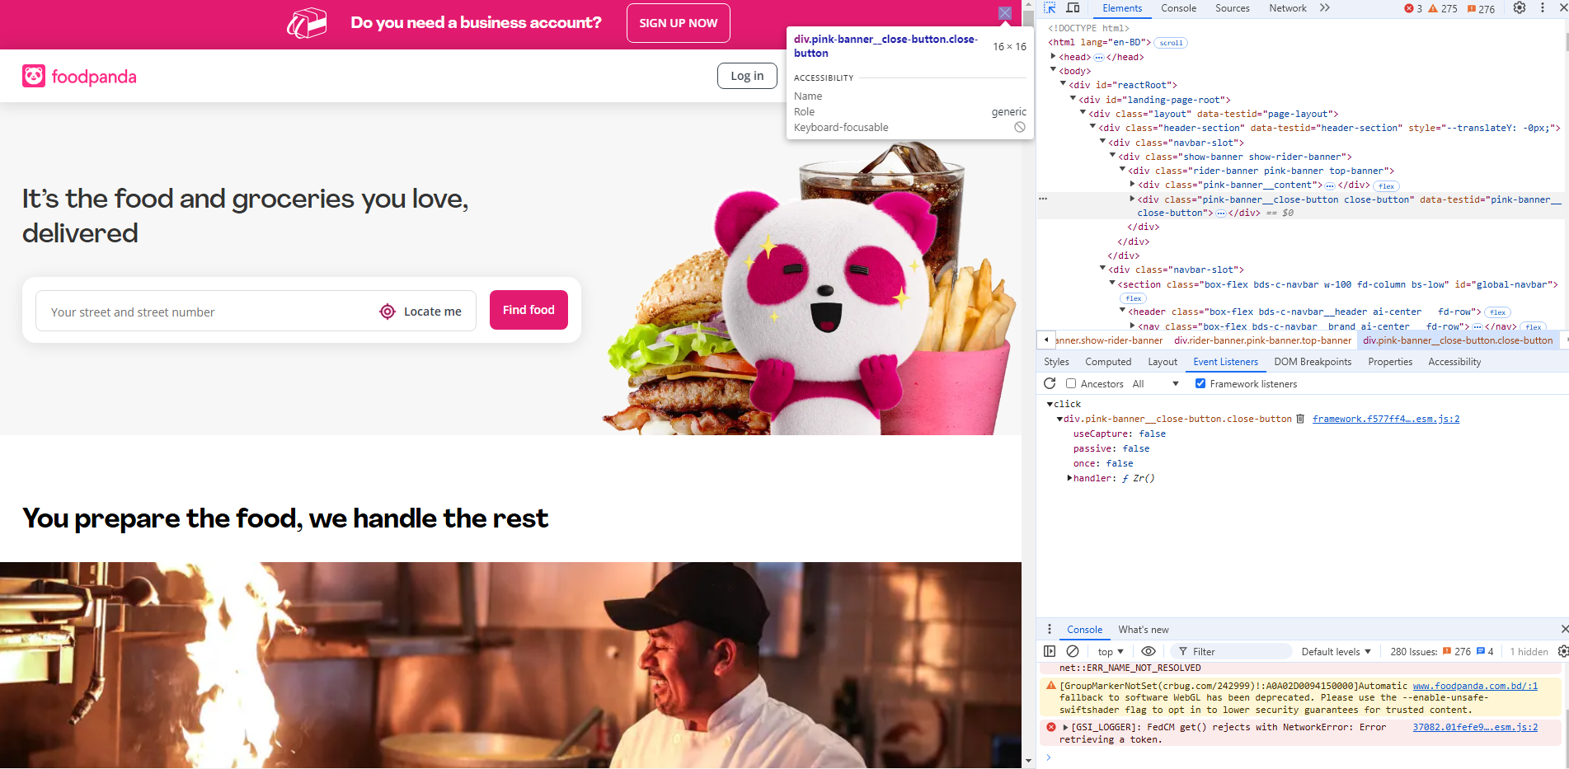
- Change the values on the Metrics pane of an element.
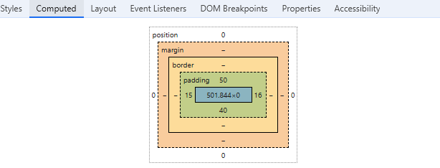

- Now, Type “Dhanmondi” in the search bar and click the “Find Food” button. Click on “Find Restaurants. Type “Pizza” in the search option.

- Check the Network tab. User filter: Fetch/XHR. Click on the “search?query=pizza…”. Check the Header, Payload and Response tab.
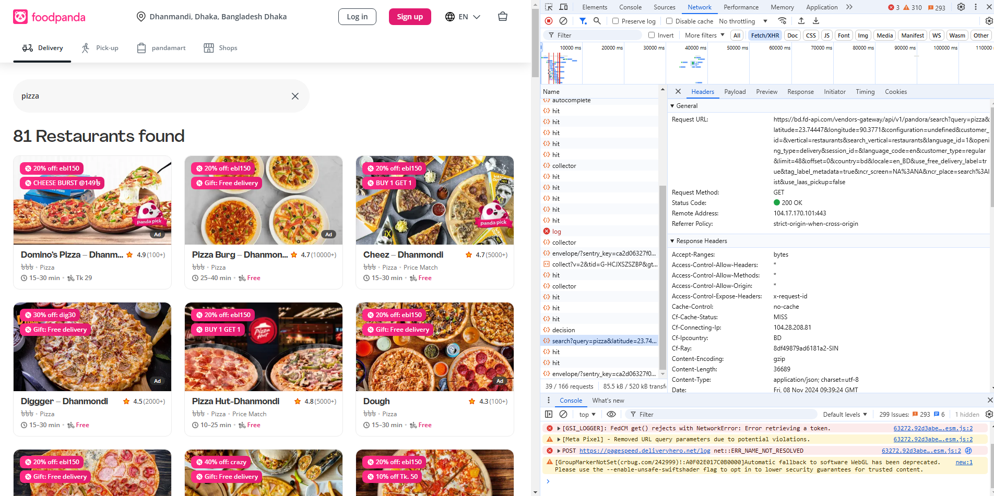

HTTP: https://www.w3schools.com/whatis/whatis_http.asp
HTTP Request Methods: https://www.w3schools.com/tags/ref_httpmethods.asp
JSON: https://www.w3schools.com/whatis/whatis_json.asp

- Change the throttling. Check the number of requests and load time in the bottom.
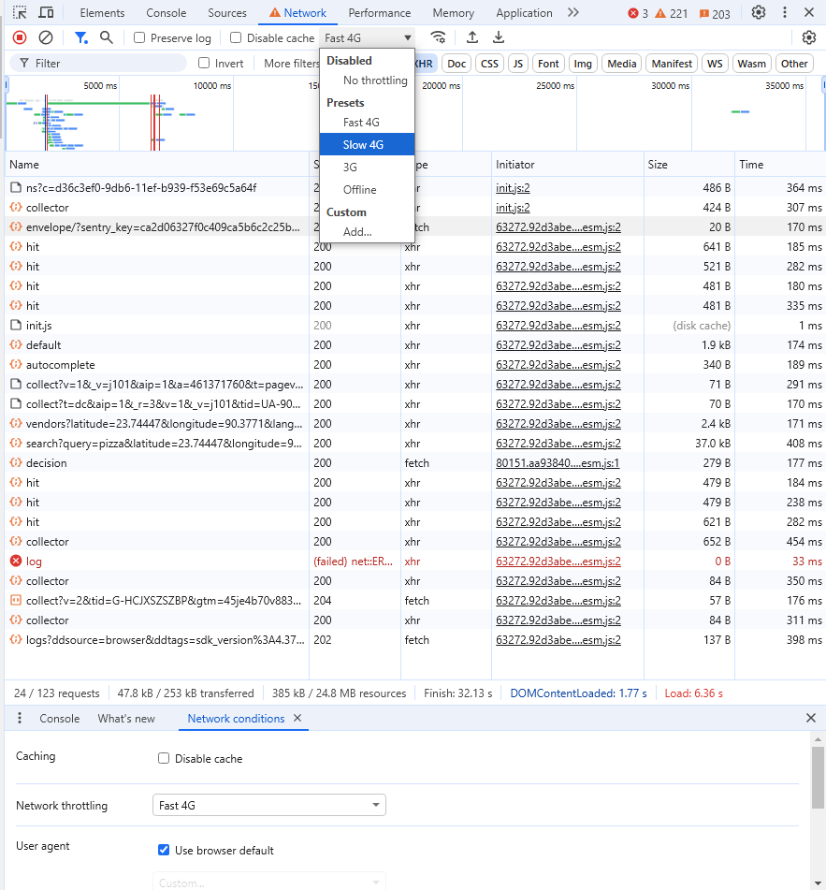

- Right click on the reload button and select “Empty Cache and hard reload”. Now, Check the Performance tab.

Largest contentful paint (LCP) provides a snapshot of how long a page's main content takes to become visible to users. A good LCP is less than 2.5 seconds. LCP between 2.5 and 4 seconds is considered "needing improvement", and above 4 seconds is considered poor.

Cumulative Layout Shift (CLS) is a metric that measures how much a webpage shifts unexpectedly while it's loading and being rendered. To improve CLS, you can reserve space for images, videos, and iframes. You can also use the CSS property aspect-ratio to set a dynamic width based on the screen size. Good CLS values are 0.1 or less. Poor values are greater than 0.25.

Repeat this experiment with a different webpage: https://dlrs.gov.bd/
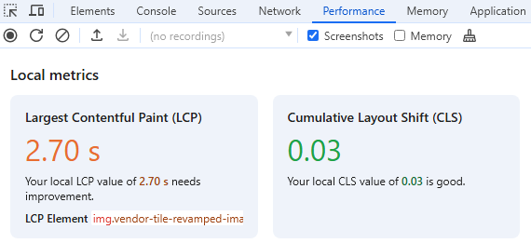
- Go to the Lighthouse tab and click the Analyze page load button.
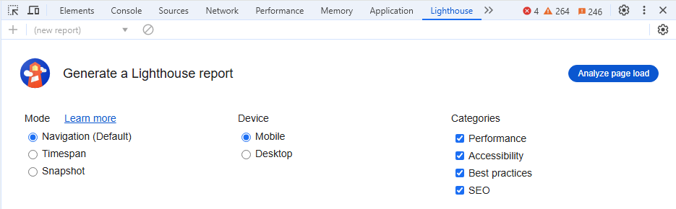
0 to 49 (red): Poor
50 to 89 (orange): Needs Improvement
90 to 100 (green): Good

Do this same experiment with another website and compare: https://dlrs.gov.bd/

- Toggle device toolbar (Ctrl + Shift + M). View the page in different viewports.
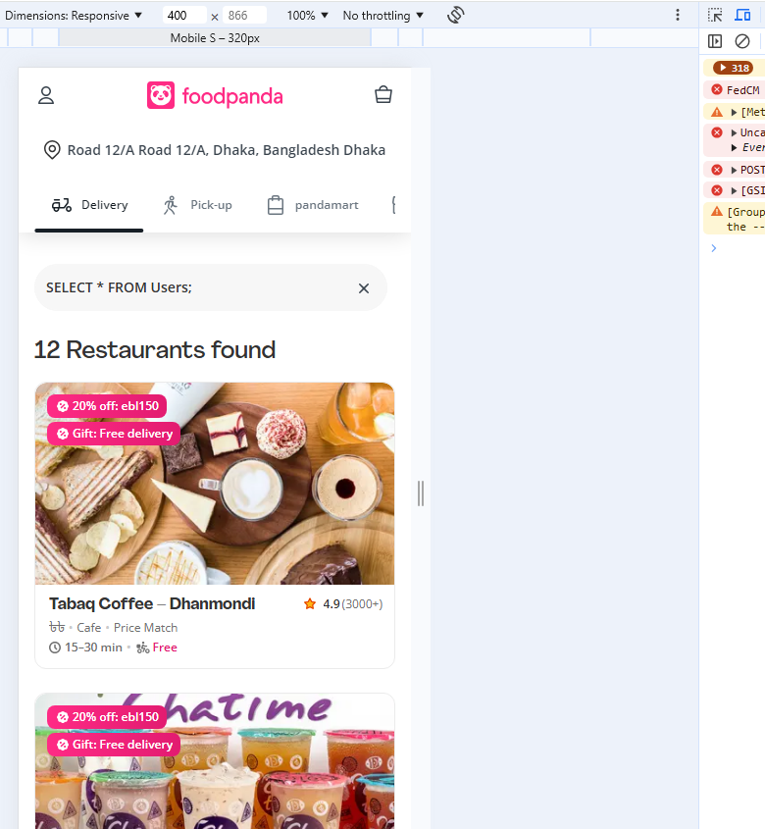

- Go to the Console tab. Console is useful because-
- Making sure that code is executing in the right order.
- Inspecting the values of variables at a certain moment in time.

- Execute the following codes in console:

console.log("Testing console");
document.title = "This page is hacked";
document.body.style.backgroundColor = "red";
const h1 = document.getElementById("rlp-vertical-switcher");
if (h1) {
console.log(h1.textContent);
} else {
console.warn("Element with id 'rlp-vertical-switcher' not found.");
}
const artists = [
{ first: "René", last: "Magritte" },
{ first: "Chaim", last: "Soutine" },
{ first: "Henri", last: "Matisse" }
];
console.table(artists);

